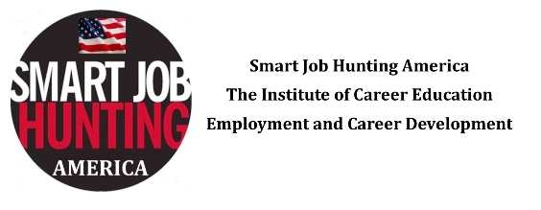Candidate Networking Profile Example
Matthew Millennial | northern New Jersey | 973-xxx-xxxx | millennial@gmail.com

TARGET COMPANIES INDUSTRIES LIST & PROFILE
Digital Journalist & Editor

I am a versatile content creator that is familiar with all aspects of digital news publishing. My work has appeared in NJ.com, Business Insider, Technical.ly, Daily Voice, Thrillist, Digital Journal, and the World Economic Forum.

BREADTH OF EXPERIENCE:

- News Writing
- Feature Writing
- Breaking News
- Investigative
- Reporting
- Headline Writing
- Data Journalism
- Viral Content
- Copy Editing
- Research & Fact Checking
- Photojournalism
- Video Production
- Social Media
- Branded Content
- Newsletters
- AP Style
- HTML
- CSS
- Java
- SEO

SELECTED ACHEIVEMENTS:
- Found, wrote and published a story for Daily Voice that received 600,000 page views, the most in company history.
- Ranked among the leaders in the Business Insider editorial department by generating content that received over two million page views each month.
- Founded and manage the official Daily Voice Snapchat and Instagram accounts.
- Nominated for a 2015 New Jersey Press Association Award for breaking news reporting.

CURRENT POSITION:
Community Editor, Daily Voice, Bergen County, NJ October 2015 — Present
- Help manage the news operation for 22 websites covering Bergen and Passaic Counties in New Jersey.
- Publish 3-4 originally reported stories daily on crime, business, municipal affairs, sports, schools and culture.
- Recruit “Community Advisors” — local community experts who provide story ideas and news tips.
- Assign stories to reporters and content creation team. Schedule and curate content on each site.
- Supplement stories with photos and video. Promote content on social media platforms.

TARGET COMPANIES:

- Buzzfeed
- Business Insider
- VICE Media
- Gawker Media
- Vox Media
- Fusion
- Yahoo News
- Mic
- New Republic
- The Washington Post
- The Pacific Standard
- The Daily Beast
- Huffington Post
- Thrillist Media
- Mother Jones
- Time Inc.
- Salon
- The Daily Mail
- Politico
- Billy Penn
- Atlantic Media
- The Guardian
- Slate
- Forbes
- Refinery 29
- Talking Points Memo
- The New York Times
- The New York Post
- Associated Press
- Christian Science Monitor

TARGET INDUSTRIES:

- Digital Media
- Print Media
- Broadcast Media
- Public Relations
- Advertising
- Branded Content

TARGET POSITIONS:

- Writer/Reporter
- Assistant Editor
- Copyeditor
- Account Manager

TARGET LOCATIONS:
New York City but willing to relocate for the right opportunity.

